Chapter 13, Problem 60.

Refer to the circuit in Fig. 13.124 below.

(a) Find currents I₁, I₂, and I₃.

(b) Find the power dissipated in the 40-Ω resistor.

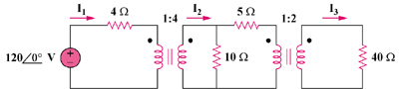

Figure 13.124
For Prob. 13.60.

